Load Beam Information Package c/w Max

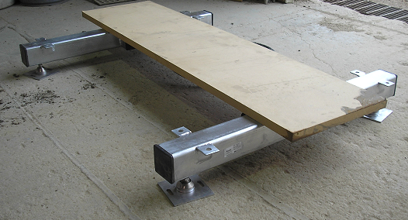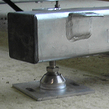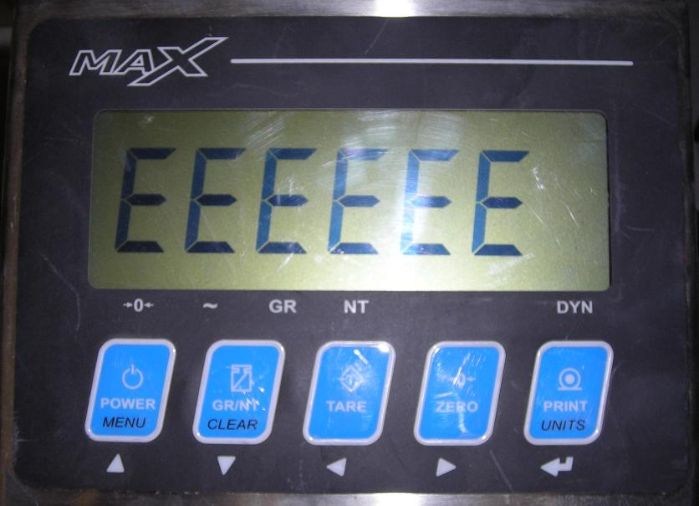

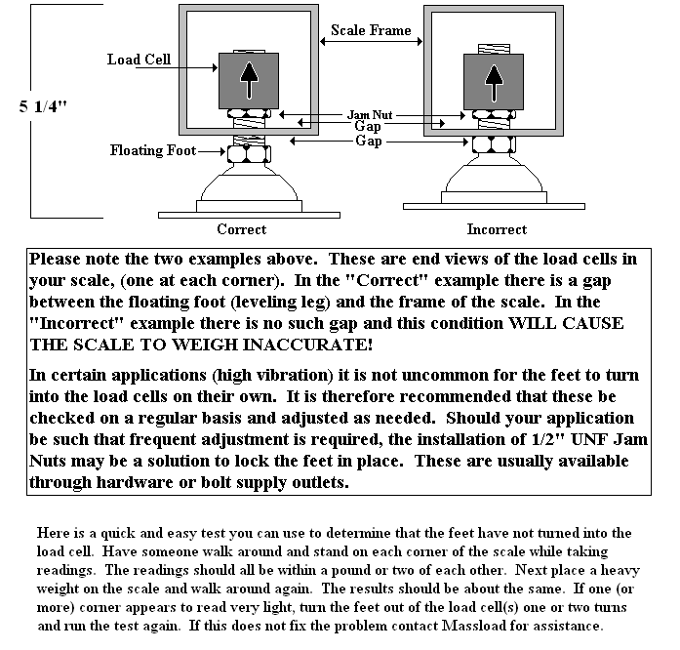

Sept., 2005
Product Update

Thank you for purchasing your load beam scale system from Massload Technologies. We genuinely hope that this system will provide years of trouble free operation in your application and to this end we also hope that this document will help to ensure that.

As you may know there are numerous manufacturers of animal squeezes, pens and weighing platforms on the market. We also know that many of our customers are ingenious in how they plan to use the product. For these reasons Massload Technologies has designed the Load Beam scale system to be as versatile as possible, but each installation is different and yet each is the same in how the Load Beams work. The fact that each customer likely has a unique apparatus mounted to their load beam scale system, makes it virtually impossible for us at Massload to provide detailed installation information. We have however, over the years, had a number of customers contact us with some very good ideas that they have incorporated into their installations that would increase the longevity of their scale systems.

For the most part components used in the load beam scale system do not fail in normal weighing applications. Having stated this, the one exception may be the “Floating Foot” assembly when used in an animal weighing application. What typically causes a “Floating Foot” to fail is from the repeated shocks from animals hitting the head end of the scale platform and or the platform lifting and then slamming down as the animal enters or leaves the scale system. Since about 95% of our customers use the load beams in exactly that application, here are a few suggestions passed on to us by other users in how they put “checks” in place to limit movement.

October, 2008

Over the past number of months a few customers have asked if they can get “floating feet” that have larger diameter thread than the ½” UNF supplied. This is not possible for the following reason:
The four ML100 load cells installed inside the load beams are referred to as “Industry Standard” cells. This means that exact type, style and capacity of load cell is produced by numerous load cell manufacturers world wide. [This means that should a load cell fail in your system, your local scale service company will have ready access to replacement cells.] As mentioned, “Industry Standard” load cells are manufactured to be inter-changeable and therefore all dimensions including thread size are exactly the same.

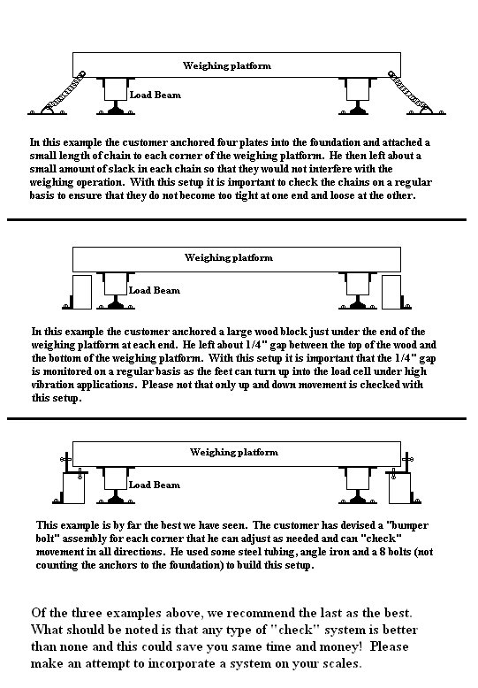

Procedure for Re-Zeroing Western Max Indicator

-Assemble any additional equipment to the weighing portion of the scale that is required for your application. Ensure that the scale is installed level by using the floating feet, and that all of the load cells will be bearing a portion of any load applied. The scale (and add-ons) must be free of interference from anything not part of the scale.

1-Power-up the Max indicator.
2-Press the <TARE> and <ZERO> keys together. The display will flash “CAL” quickly, “PASS” quickly and then show -0000- with the far right digit flashing. Press <MENU> to change the flashing digit to 1. With -0001- on the display press <PRINT> to enter.
3-The display will now show the first parameter “P 1.0”.
4-Use the <MENU> key to go to “P 1.2”. Press the <PRINT> key to drop down. The display should read “E SCL” (empty scale?). Make sure that only the weight of the squeeze or deck is on the scale(s).
5-Press <PRINT> to perform the deadload (zeroing of the scale). When completed the display will say “dOnE”.
6-Press the MENU> key to get “P 1.3” on the display.
7-Press the <TARE> and <ZERO> keys together to exit the programming and calibration mode.

*** Each weighing application is slightly different. If you find that the “factory” setup of your scale system is not meeting your needs please contact Massload. Do not attempt to make alterations of the setup programming without assistance!

